**My Website**

As a personal project, I am learning how to use HTML and CSS in my free time. I have started my own website but it is currently only around 70% completed. This document includes some screenshots from my website and information about it to demonstrate my web development and design skills. Enjoy!

My website is currently split into five pages as displayed on my home page. The home page contains the about me and contact info sections.

**Home Page**

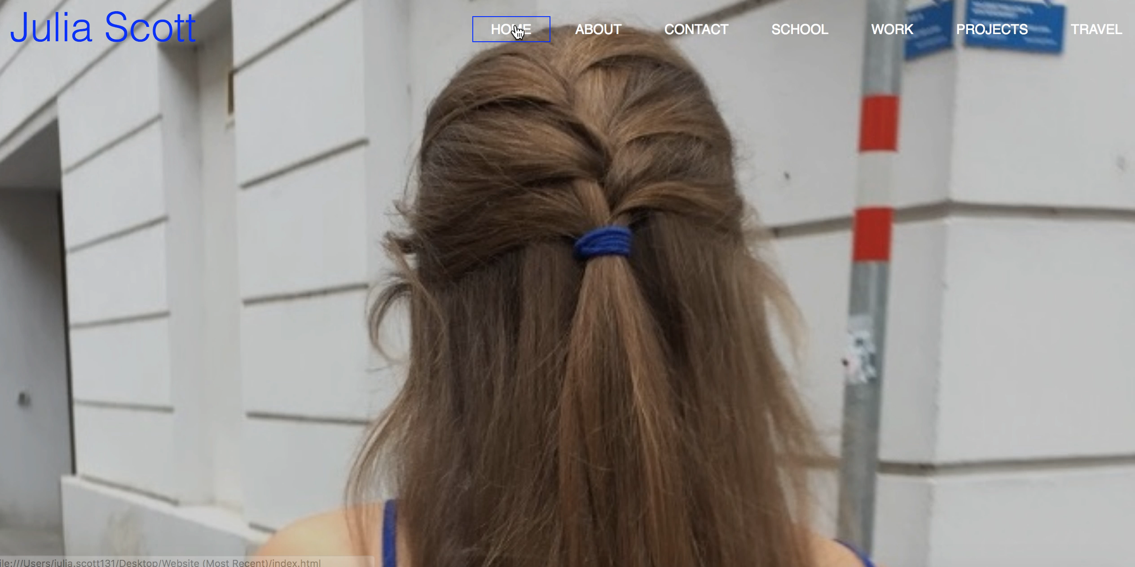

**Projects**

Information included in my website outlines my work experience, education, personal projects and travel!

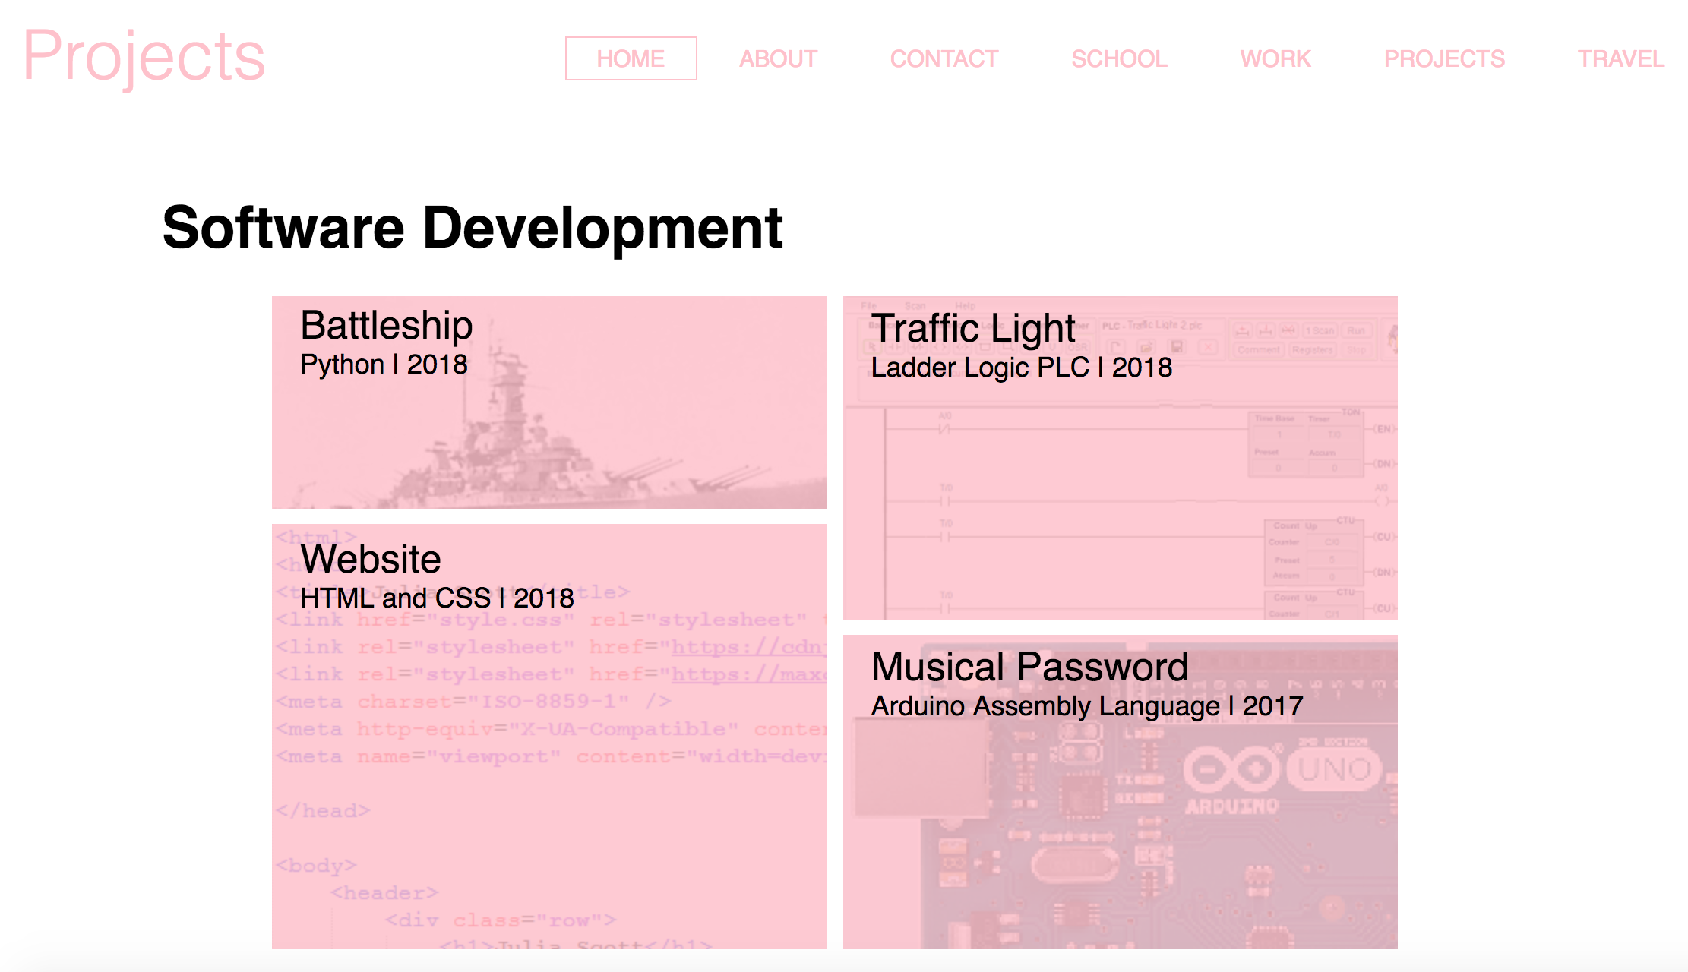

**Travel**

**Education**

